**Installation of the Windows operating system**



Session: 2022 – 2026

**Submitted by:**

Rida Mushtaq 2022-CS-168

Asim Ali Murtaza 2022-CS-175

**Supervised by:**

Mr.Nauman Shafi

Department of Computer Science

**University of Engineering and Technology**

**Lahore Pakistan**

**Lab Task**

“Windows Installation Procedure”

1. Download Virtual Box or VMware Player 17 and install it on your machine. Add the ISO image to Virtual Box to add it to your library.
2. Download the Win ISO file from <https://www.microsoft.com/en-us/software-download/windows10> or use media creation tool to make bootable usb drive.

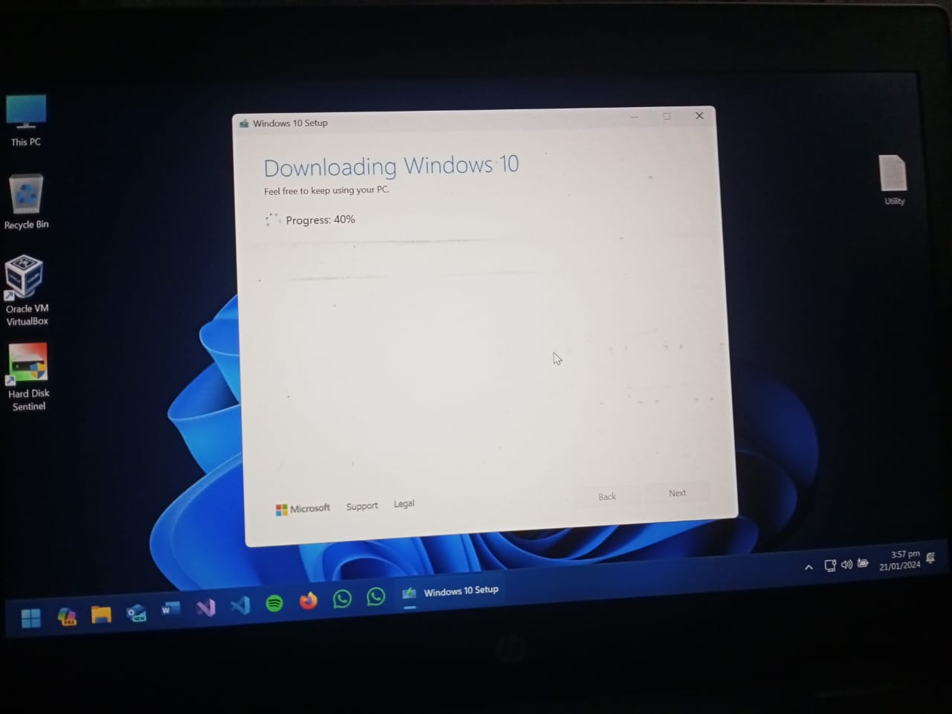

1. Start the Windows 10 VM and let it power on. After powering it on, the installation process will begin.

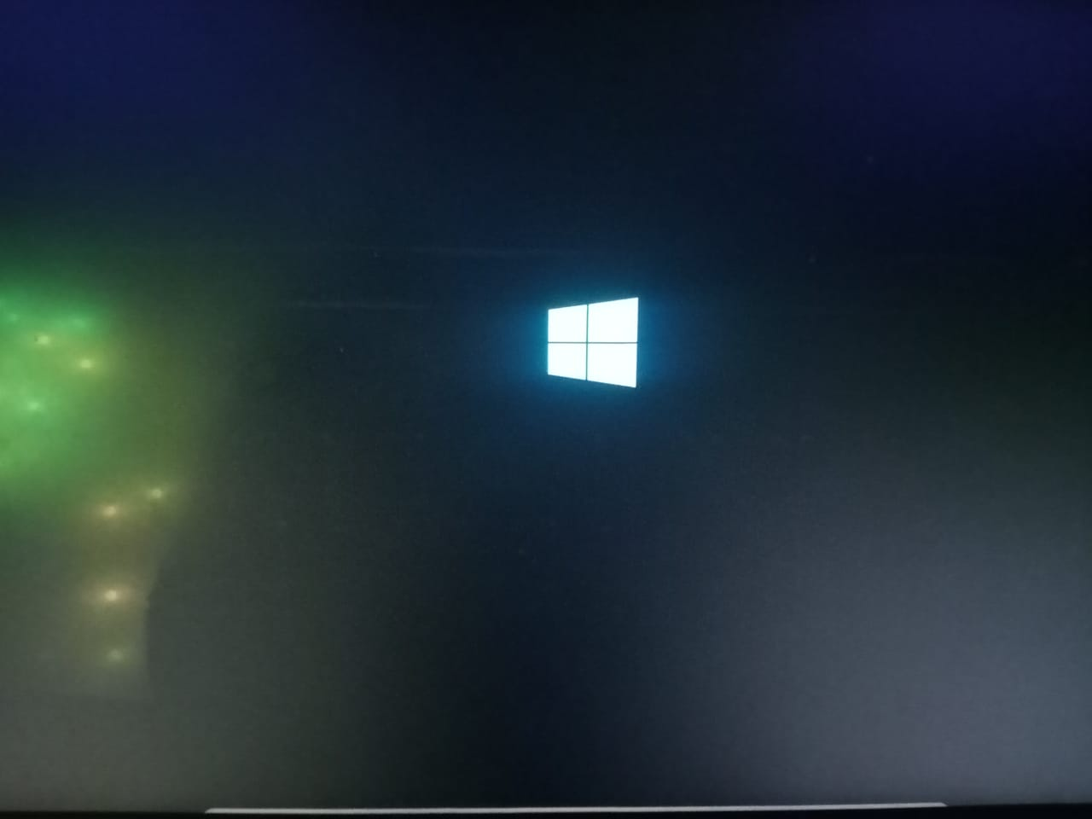

The VM will boot into Windows 10 setup

1. The windows setup is starting.

1. The windows files will be copied into your system and the installation will begin. This process may take around 15-20 minutes depending on your resources allocated for the VM.

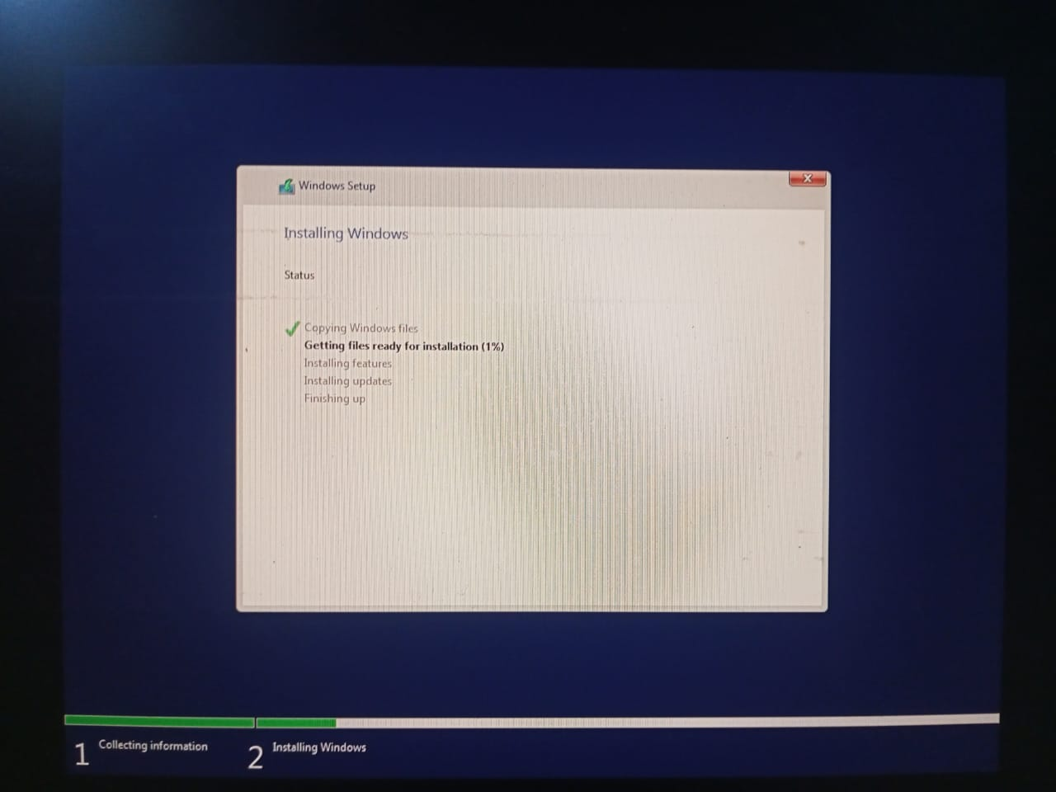

1. The Windows Installation has started.

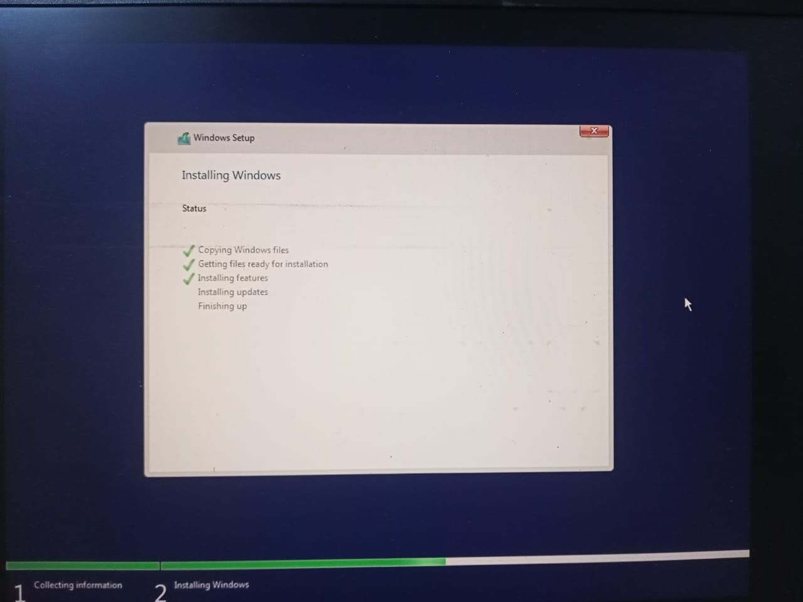

1. After the files are ready for installation, the windows features and updates will be installed. This process may take about 10-15 minutes.

1. After installing required features, the windows installation is finishing up.

1. After finishing up, the VM will restart.

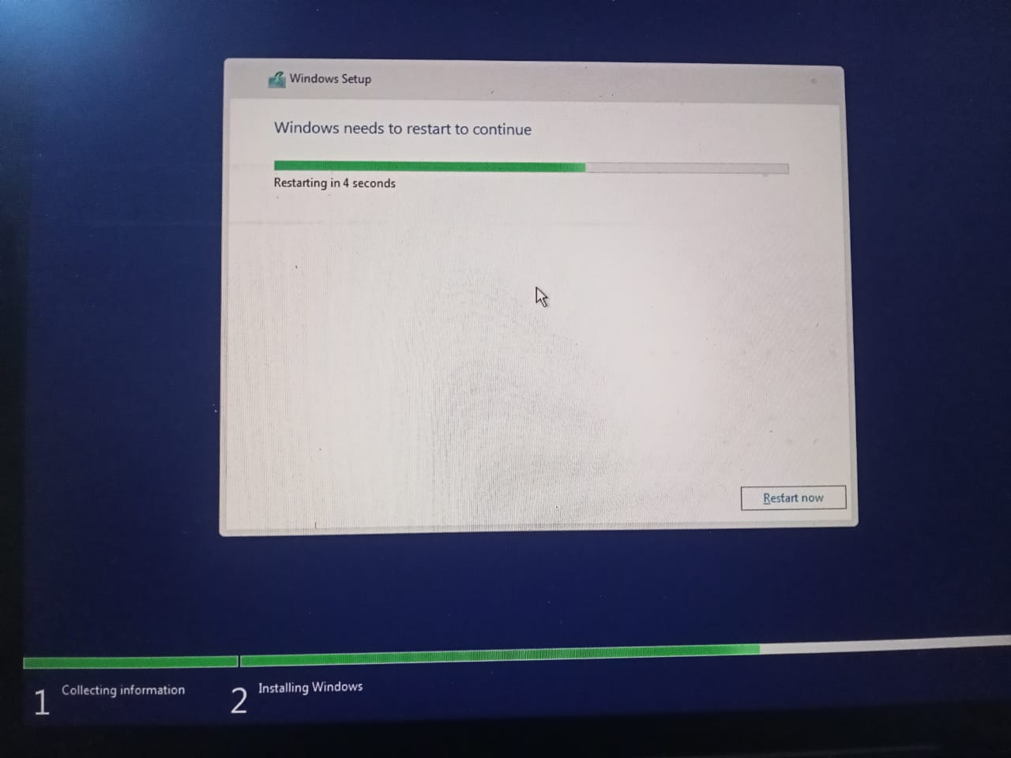

1. After rebooting, the windows services will start.

1. After this step, the windows will prepare for first boot.

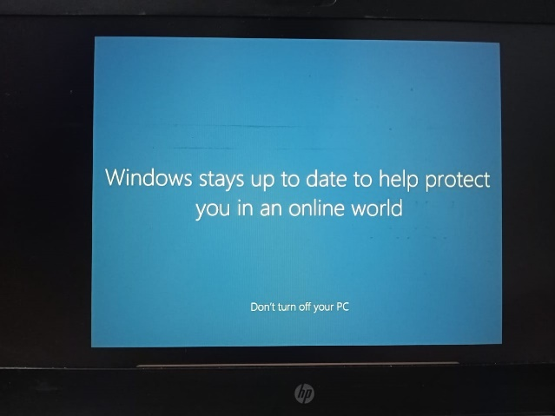

1. After 10-15 minutes, the windows desktop will show up.

